“BOB GILL STORY”

BOB GILL IS A DAREDEVIL LEGEND FROM THE 1970s.

HE IS A WORLDWIDE MOTORCYCLE CHAMPION.
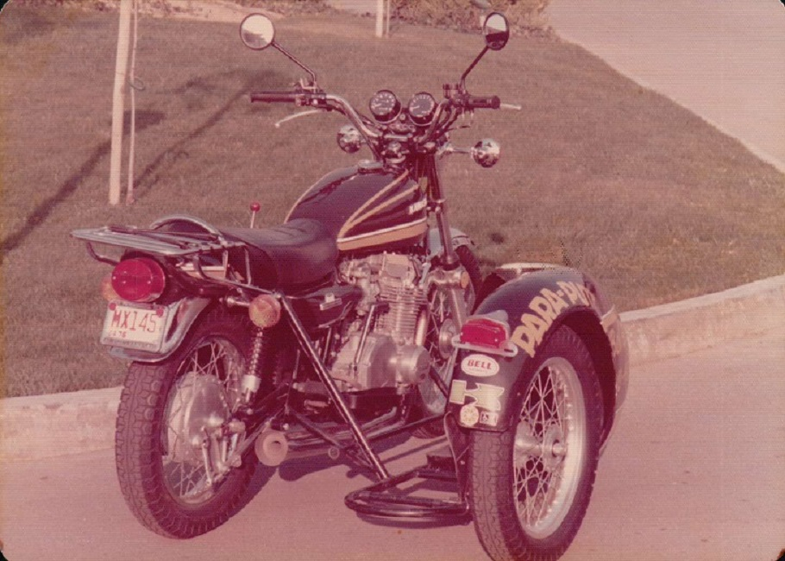
BOB WAS SPONSORED BY KAWASAKI MOTOR CORPORATION, THE UNITED STATES NAVY,

VALVOLINE MOTOR OIL AND WINNEBAGO MOTOR HOMES, TO NAME A FEW.

THIS BIKE IS A 1973 KAWASAKI Z1 SUPER BIKE.

IT CAME OVER ON THE FIRST BOATLOAD AND WAS GIVEN TO BOB BY KAWASAKI.

THIS BIKE HAS A HUGE HISTORY. NOT ONLY DID BOB CARRY IT ON HIS TOUR,

BUT ALSO AFTER HIS ACCIDENT IN 1974, LEAVING BOB WITH A SPINAL CORD INJURY, HE

CONVERTED THIS BIKE HIMSELF TO BE HAND CONTROLLED. AND HE BUILT THE

SIDECAR TO CARRY HIS WHEELCHAIR. IN 1976, THE 200th BIRTHDAY OF OUR

COUNTRY, BOB RODE THIS BIKE 8,000 MILES ACROSS COUNTRY FROM ST. PETERSBURG, FL TO

HOLLYWOOD, CA BY WAY OF BOSTON, MA, HOLDING

PRESS CONFERENCES IN 30 MAJOR CITIES, FOR SPINAL CORD INJURY,

RAISING OVER $1.2 MILLION DOLLARS.

IN THE YEAR 2012, BOB DECIDED TO RECONSTRUCT, AND DO A REMAKE OF HIS BIKE

HAVING M.R.E., MURDOCK RACING ENTERPRISES, BUILD HIM A 1200cc, HIGH PERFORMANCE,

165hp ENGINE, AND A COMPLETE REMAKE ON THE PAINT, AND MAJOR COMPONENTS.

BOB IS NOW 71 YEARS OLD, AND HIS WIFE, SHARON, 73. THEY RIDE THE BIKE ALL OVER AND

GO TO RALLIES AND BIKE SHOWS LIKE QSL IN FLORIDA. AND SOMETIMES OUT OF STATE.

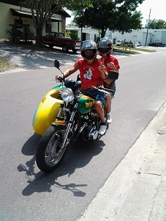

BARNEY’S MOTORCYCLE SALES IS WHERE BOB GOT HIS START, RIDING ON THE STREET

AND RACING ON BARNEY’S RACING TEAM IN THE 1960s.

BOB CONSIDERS BARNEY A SECOND DAD, AS HE TAUGHT HIM EVERYTHING ABOUT

BEING A MECHANIC, AND A SERVICE MANAGER, AND BUILDING HIGH PERFORMANCE RACING ENGINES.

BOB’S RACING CAREER RANGED FROM 1962 TO 1970. AND HIS JUMPING CAREER FROM 1970 TO 1974

WHEN HE WAS INJURED.

BOB WON THE 1964 SEBRING INTERNATIONAL ROAD RACE IN SEBRING, FLORIDA.

HE GAINED THE NAME “FLORIDA FLYER” FROM THAT WIN AND THE 1965 DUCATI WAS NAMED “SEBRING”.

BOB HOLDS MANY WORLD RECORDS. SOME OF HIS BIGGEST PERFORMANCES WERE: JUMPING THE WHOLE

FLEET OF RYDER TRUCKS FOR SUPER BOWL VIII,

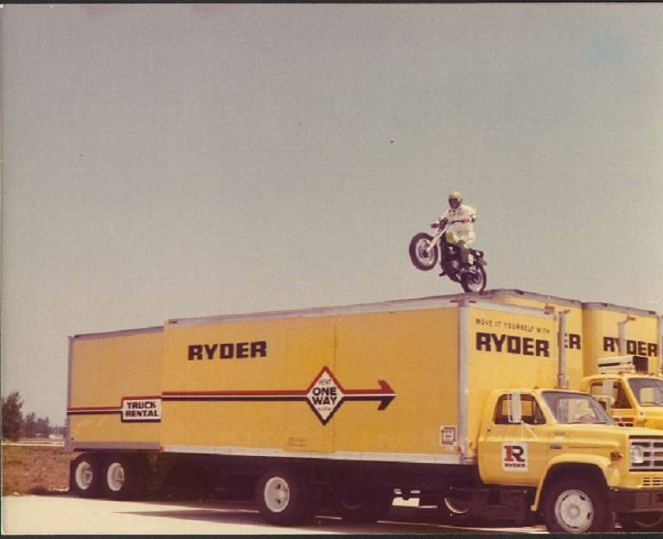

THE FIRST TO JUMP A CANYON IN NEW ORLEANS, HE SET

THE GUINNESS BOOK OF WORLD RECORDS, JUMPING 22 CARS, 171 FEET AT SEATTLE INTERNATIONAL

RACEWAY. AND HE DID ALL THIS WITHOUT A LANDING RAMP.

BOB IS THE ONLY ONE TO SUCCESSFULLY JUMP IN THE WORLD FAMOUS SAN FRANCISCO COW PALACE.

EVEL TRIED IT TWICE AND FELL BOTH TIMES. BOB ALSO JUMPED 19 CARS IN CARRACAS, VENNEZUELA IN FRONT

OF 140,000 LIVE FANS ON THE PARADE GROUNDS.

BOB’S FOUR YEAR CAREER CONSISTED OF 165 PERFORMANCES IN FRONT OF A LIVE AUDIENCE.

ALL WITHOUT A LANDING RAMP.

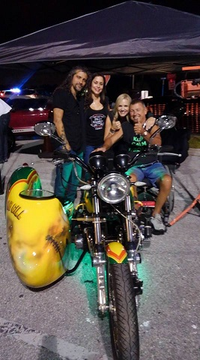

“MY BIKE WON 1st PLACE OVERALL 2016 AT QSL WITH DANIEL AND THE FRAN-TASTICS”

